# CyberSecurity Guide (PART I)

* **Confidentiality:** Protects information and systems from unauthorized access.
* **Integrity:** Protects information and systems from unauthorized modification.
* **Availability:** Ensures information and systems are available for authorized users when needed.



**Accounting:** The system logs your activities for future reference.

**Authorization**: The system checks if you have permission to access certain files or systems.

**Authentication**: You enter your password (or use another method like a fingerprint).

**Identification**: You enter your username.

## Security Controls:

Security controls are measures put in place to protect an organization from security risks. Let’s think of them as different tools and strategies to keep your home safe.

|  |  |  |
| --- | --- | --- |
|  | **Preventive Controls**: These aim to stop security issues before they happen. For example, a |  |
|  | firewall that blocks unwanted traffic is like a lock on your door. |  |
|  |

|  |  |  |
| --- | --- | --- |
|  | **Detective Controls**: These identify potential security breaches. An intrusion detection system is |  |
|  | like a burglar alarm that alerts you if someone tries to break in. |  |
|  |

|  |  |  |
| --- | --- | --- |
|  | **Corrective Controls**: These fix issues after they occur. Restoring data from a backup after an |  |
|  | attack is like fixing a broken window after a burglary. |  |
|  |

|  |  |  |
| --- | --- | --- |
|  | **Deterrent Controls**: These discourage attackers from trying. Guard dogs or security cameras act |  |
|  | as deterrents. |  |
|  | |

|  |  |  |
| --- | --- | --- |
|  | **Directive Controls**: These provide guidelines on what to do. Policies and procedures are like |  |
|  | instructions for using your home security system. |  |
|  | |

|  |  |  |
| --- | --- | --- |
|  | **Compensating Controls**: These fill gaps in your security. If a gate is easy to jump over, placing a |  |
|  | guard there compensates for that weakness |  |
|  |

* **Technical Controls:** These use technology to achieve security. Examples include firewalls, encryption, and antivirus software.
* **Operational Controls:** These are processes carried out by people to manage security. Examples include user access reviews and security training.
* **Managerial Controls:** These focus on managing risks. Conducting regular risk assessments and security planning are examples.
* **Physical Controls:** These protect the physical environment. Examples include locks, fences, and fire suppression systems.

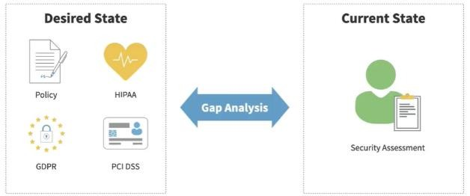

**Conducting Gap Analysis**

**Desired State**: Identify the ideal state of your information security program, considering both internal policies.

and external regulatory requirements.

**Current State**: Assess the current state of your cybersecurity controls, either internally or with the help

of a security consultant.

**Gap Analysis**: Compare the current state to the desired state to identify control gaps. These gaps are

areas where your current controls fall short of the desired state.

**Remediation and Roadmap**: Prioritize and plan remediation efforts to address the identified gaps. This roadmap helps align your activities with your organization's security needs and can span several years depending on the complexity and resources available.

**Zero Trust Network Access (ZTNA)** and **Secure Access Service Edge (SASE)** are modern approaches to network security.

Zero Trust Network Access (ZTNA)

* **Core Principle**: Trust no one by default, whether inside or outside the network. Every user and device must be verified before accessing resources.
* **Least Privilege**: Users only get access to the resources they need for their role, nothing more.
* **Network Location Irrelevant**: It doesn't matter if users are in the office, at home, or on the road. Location alone doesn't grant access.

How ZTNA Works

## Control Plane vs. Data Plane:

* + **Control Plane**: Where decisions about access are made.
  + **Data Plane**: Where access is granted based on those decisions.

## Key Capabilities:

* + **Adaptive Identity**: Supports various user roles and identities that may change over time.
  + **Threat Scope Reduction**: Keeps the environment simple to minimize risks.
  + **Policy-Driven Access Control**: Flexible access control that adapts to changing needs.
  + **Implicit Trust Zones**: Zones for sensitive data, like personal information or credit card data, that require extra protection.

## NIST Model:

* + **Policy Enforcement Point (PEP)**: Intercepts access requests and enforces decisions.
  + **Policy Decision Point (PDP)**: Consists of:
    - **Policy Engine**: Decides whether to grant or deny access.
    - **Policy Administrator**: Configures the PEP based on the decision.

Secure Access Service Edge (SASE)

* **Higher-Level Design**: Combines ZTNA with other network security services like cloud access security brokers and firewalls.
* **Long-Term Goal**: Organizations gradually evolve their networks to support SASE, integrating outdated and new technologies.

Practical Implications

* **Short-Term**: Adopt Zero Trust principles to secure remote workforces and cloud services.
* **Long-Term**: Plan new networking projects with SASE in mind for future integration.

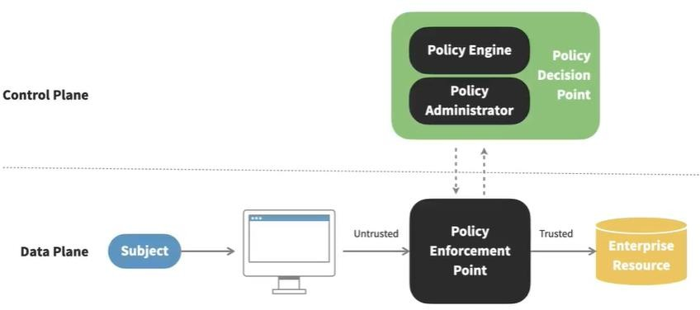

**Types of Locks**:

# Physical Access Control

* + **Preset Locks**: Traditional locks that require a specific physical key.
  + **Cipher Locks**: Use a keypad where you enter a combination.
  + **Biometric Locks**: Use physical characteristics like fingerprints or retinal patterns.
  + **Card-Based Locks**: Use cards (magnetic stripe or proximity) to grant access.

## Key Management:

* + It's crucial to keep track of who has which keys and change locks if keys are lost or stolen.

## Tailgating:

* + This occurs when an unauthorized person follows an authorized person through a door. Access control vestibules (two-door systems) help prevent this by verifying only one person enters at a time.

## Sensors for Monitoring:

* + **Motion Sensors**: Detect movement.
  + **Noise Sensors**: Monitor unexpected sounds like glass breaking.
  + **Pressure Sensors**: Detect footsteps.
  + **Microwave and Ultrasonic Sensors**: Use advanced technology to detect presence.

## Video Surveillance:

* + Acts as both a deterrent and a detective control. Cameras can be monitored by security personnel or software to detect unauthorized access.

## Physical Barriers:

* + **Fences and Cages**: Prevent unauthorized access to areas.
  + **Bollards**: Prevent vehicles from crashing into buildings.
  + **Lighting and Signs**: Increase visibility and provide legal grounds for trespassing charges.

## Industrial Camouflage:

* + Hiding sensitive facilities to make them look like ordinary buildings, which is increasingly challenging with drones.

# Physical Security personnel

## Role of Human Guards:

* + **Human Judgment**: Security personnel use their judgment to evaluate visitor requests and grant access. This human element is crucial as technology alone can't always make these decisions.
  + **Welcoming Presence**: Guards can serve as a welcoming face to visitors while still performing important security functions. They might appear as receptionists but are ensuring security.

## Types of Security Guards:

* + **Overt Uniformed Guards**: These guards are visible and project an air of security and authority. Depending on local regulations, they can be armed.
  + **Robot Sentries**: These are automated guards that patrol facilities, looking for abnormal activities and either challenging intruders or summoning human responses.

## Two-Person Rule:

* + **Two-Person Integrity**: This policy requires two people to be present for access to sensitive areas, deterring unauthorized activity by a single person.
  + **Two-Person Control**: Requires the agreement of two individuals to perform a sensitive action, like launching a nuclear missile. This ensures that no single person can perform the action alone.

# Deception Technologies



**Darknets**: Set up darknets within your network to identify unauthorized reconnaissance activities. Any traffic detected in these areas can be flagged for further investigation, helping you proactively identify potential threats.

**Honeytokens and Honey files**: Insert fake records and files into your databases and file systems. These decoys can help you detect unauthorized access attempts. For example, a fake email address in your database can alert you if someone tries to use it, indicating a breach.

**Honeytokens and Honey files**: Insert fake records and files into your databases and file systems. These decoys can help you detect unauthorized access attempts. For example, a fake email address in your database can alert you if someone tries to use it, indicating a breach.

**Honeytokens and Honey files**: Insert fake records and files into your databases and file systems. These decoys can help you detect unauthorized access attempts. For example, a fake email address in your database can alert you if someone tries to use it, indicating a breach.

**Change Management**

## What is Change Management?

* + It's a way to plan, implement, and monitor organizational IT system changes to minimize risks and maximize benefits.

## Key Steps in Change Management:

* + **Approval Process**: Before making any changes, they must be reviewed and approved to avoid unauthorized modifications.
  + **Assigned Owner**: Each change has a person responsible for it, ensuring accountability.
  + **Stakeholder Involvement**: Involve the right people (like IT staff and department heads) to understand the impact of changes.
  + **Impact Analysis**: Assess potential risks and consequences of the change.
  + **Testing**: Verify the change works as intended without causing issues.
  + **Back-Out Plan**: Have a plan to revert the change if something goes wrong.
  + **Scheduling**: Implement changes during maintenance windows to minimize disruptions.
  + **Standard Operating Procedures (SOPs)**: Follow consistent guidelines to ensure changes are made correctly.

## Technical Considerations:

* + **Allow/Deny Lists**: Control what actions are permitted or blocked.
  + **Restrictions**: Limit certain activities to enhance security.
  + **Downtime**: Plan for temporary service interruptions.
  + **Service Restarts**: Restart applications to apply changes.
  + **Legacy Applications**: Ensure changes don't affect older systems.
  + **Dependencies**: Understand how changes affect other systems.

## Documentation and Version Control:

* + **Version Control**: Keep records of all changes for traceability.
  + **Update Documentation**: Revise diagrams, procedures, and policies to reflect the new state after changes.